Experiment 6

Harsh – 2401010096

Aim:

Create Client_master with the following fields (ClientNO, Name, Address, City, State, bal_due)

Code:
Create database cm; use cm;
CREATE TABLE Client_master ( ClientNO VARCHAR(10) PRIMARY KEY, Name VARCHAR(50),
Address VARCHAR(100), City VARCHAR(50),
State VARCHAR(50),
bal_due DECIMAL(10,2)
);

Insert five records
INSERT INTO Client_master VALUES
('C101', 'Rahul Sharma', 'MG Road', 'Delhi', 'Delhi', 4000),
('C102', 'Priya Verma', 'Park Street', 'Kolkata', 'West Bengal', 6500), ('C123', 'Amit Singh', 'Link Road', 'Mumbai', 'Maharashtra', 3000), ('C104', 'Neha Gupta', 'Brigade Road', 'Bangalore', 'Karnataka', 7200), ('C105', 'Rohit Mehta', 'Ashram Road', 'Ahmedabad', 'Gujarat', 5500);
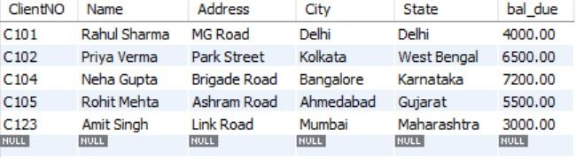

Find the names of clients whose bal_due> 5000 .
SELECT Name FROM Client_master
WHERE bal_due > 5000;

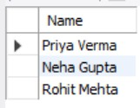

Change the bal_due of ClientNO “ C123” to Rs. 5100
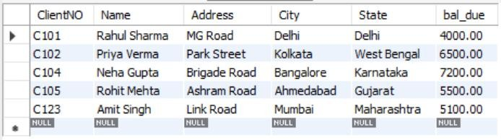
UPDATE Client_master SET bal_due = 5100 WHERE ClientNO = 'C123';

Change the name of Client_master to Client12.
ALTER TABLE Client_master RENAME TO Client12;

Display the bal_due heading as “BALANCE”
SELECT ClientNO, Name, Address, City, State, bal_due AS BALANCE FROM Client12;
